Chronology of Appomattox County, VA beginning with Henrico CO.
Showing locations of Wreck Island Creek, Bent Creek, and the northeastern area.
Compiled by D Phelps 10/8/2016
Version 3

Sources for property records
- Albemarle Plat book 1744-1853:
- Buckingham Co, VA Surveyor’s Plat Book 1762-1858 Second Edition.
- Buckingham Land Tax Summaries & Implied Deeds 1782-1814 Vol 1 NOTE: All are complete except for a) from 1783 to 1786 only a few (about 50) corrections and transactions were noted, and b) 1808 when a VA act prevented taxes
- Buckingham Land Tax Summaries & Implied Deeds 1815-1840 Vol 2) The author of Vol. 2 noted with “#” if the name appeared in the earlier Vol. 1 This # has been replaced by the comment “also seen in Vol 1”.
- 1787 Personal Property Tax Buckingham County

- Three maps of are included at the end.

- Bucholtz Map 1859 from “The 1787 Census of Virginia Buckingham County” which reports two Williams
- Old Buckingham 1761-1845 found in “Buckingham Co, VA Surveyor’s Plat Book 1762-1858 Second Edition”

By 1845 the three main areas of Phelps were located as shown:

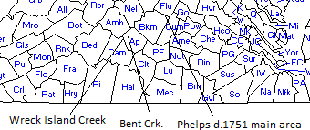

The formation of the counties

1634 Henrico formed Wreck Island Creek is possibly in two counties: Henrico and Accawmack. Bent Creek is in Henrico

1728 Goochland formed from Henrico Wreck Island Creek is in two counties: the corner of SW Goochland and NW Buckingham. Bent Creek is in Albemarle

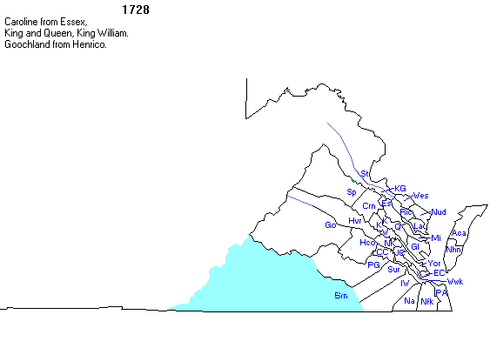
1744 Albemarle formed from Goochland
1744
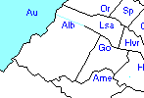

Wreck Island Creek and Bent Creek are in Albemarle.

1744 Albemarle Plat books begin.

1753 Bedford from Albemarle
1753

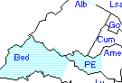

Wreck Island creek is at the mi- point of boundary of Albemarle and Bedford., so Wreck Island Creek is likely in both Albemarle and Bedford

1761: Buckingham formed from Albemarle and Bedford
1761

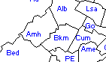
WI Creek area is at corner area of Amherst, Buckingham and Bedford. Likely WI Creek is in Buckingham and Bedford. Bent Creek is in Buckingham.

1762: Buckingham Surveyors plat book begins

1781/2: Campbell formed from Bedford. Wreck Island Creek continues to straddle the line between Campbell and Buckingham; Bent Creek in Buckingham
Before 1782

Notice the apparent straight county line in SW Buckingham

1782

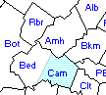

Notice the same apparent straight county line of SW Buckingham and NW Campbell that remains.

1782: Buckingham deed books begin
1840: Buckingham deed books ends

1845 Appomattox formed from Buckingham, Campbell, Charlotte, and Prince Edward- Both Wreck Island and Bent Creek in Appomattox, although some question if all of Wreck Island creek is in Appomattox
1853 Albemarle Plat books end

1858: Buckingham Surveryor’s Plat book ends.

Large maps follow below

MAPS
Bucholtz Map 1859 from “The 1787 Census of Virginia Buckingham County” which reports two Williams

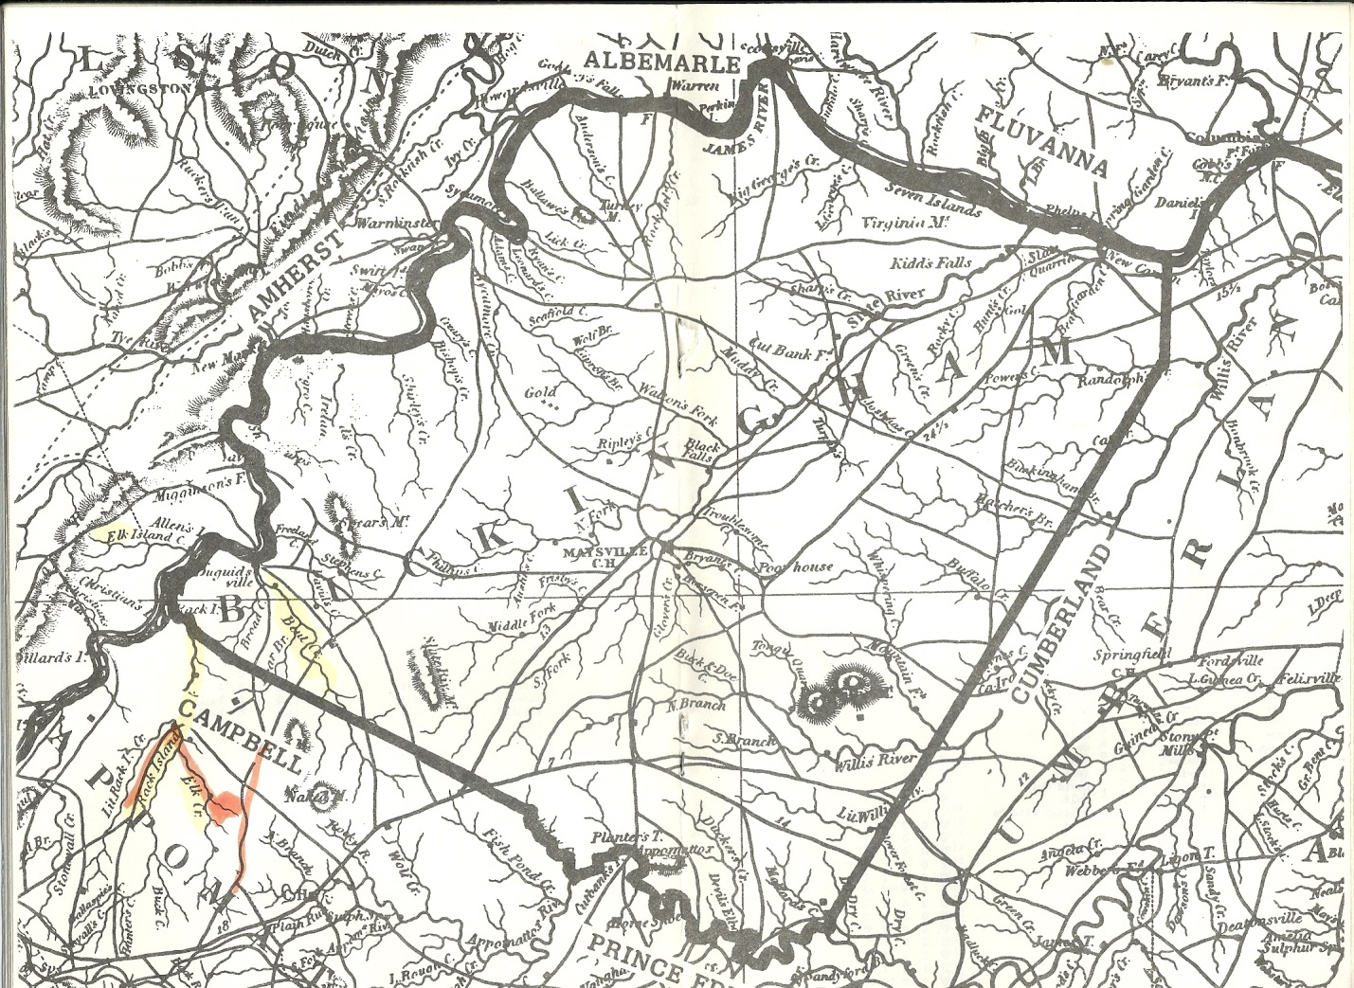
Kathie Mann points out: Elk River and Wreck island in lower left. Little Wreck Island beside.Wreck Island. Just north of that area is Bent Creek . Just north of that is Davids Creek (better seen in the following map. To the upper right northeaster corner of the map is Phelps Island and New Canton

Old Buckingham 1761-1845 found in “Buckingham Co, VA Surveyor’s Plat Book 1762-1858 Second Edition”
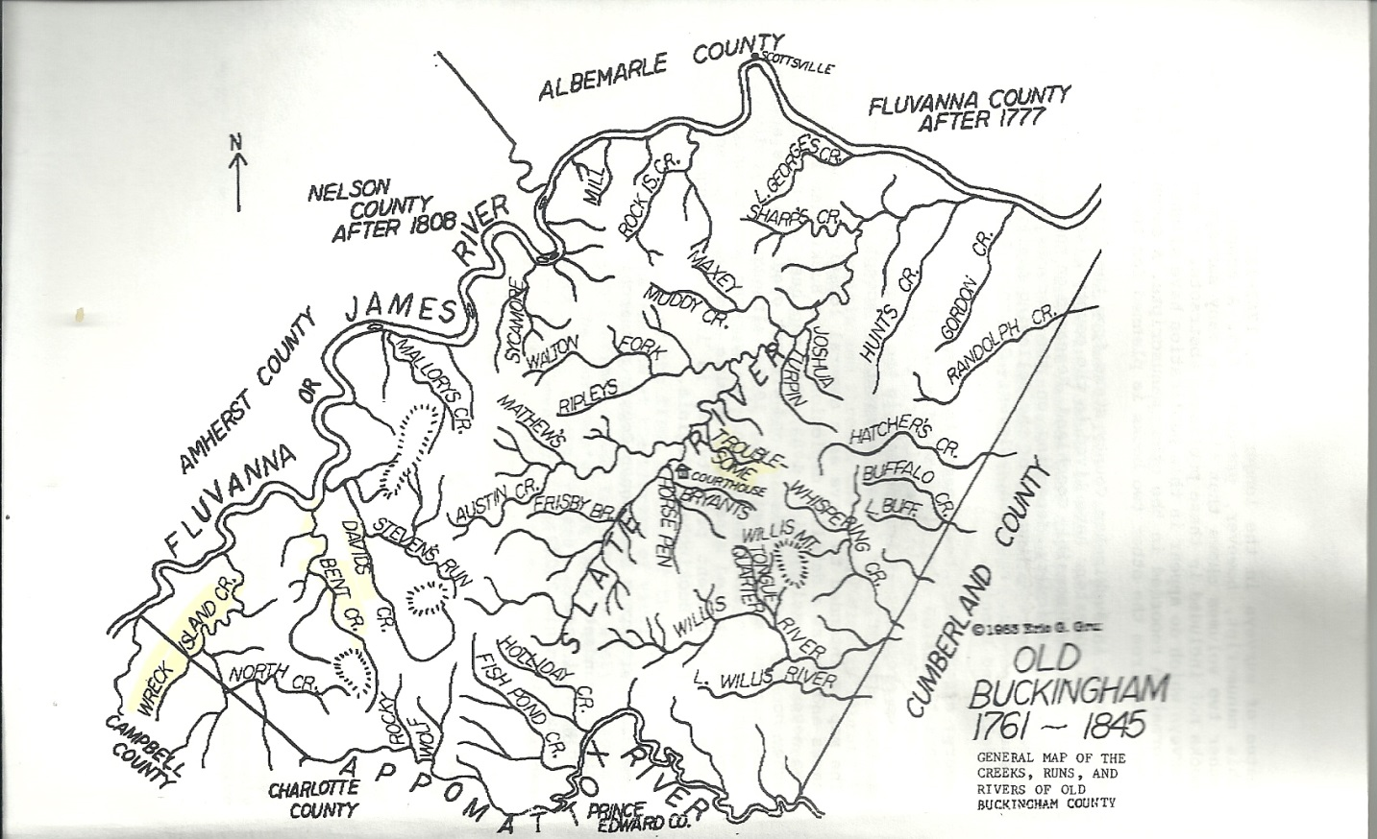

Slate River is a major river running from SW to NE, ending at the Fluvanna/James River.

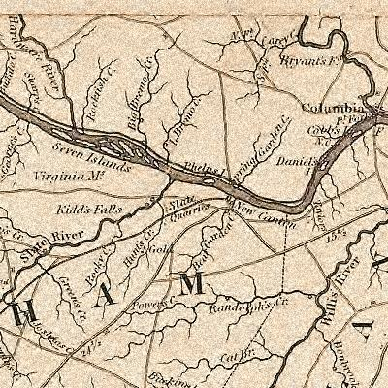
From http://www.genealogy.com/ftm/p/h/e/Marilyn-A-Phelps/PHOTO/0001photo.html “Site of the Island and Plantation of Thomas and Elizabeth Phelps of Albemarle Co., VA.Thomas died in 1751 and Elizabeth died in 1772.”
From Kathie Mann: . Look left. Seven Islands- Nicholas owned this (the one James sells land to) and Bremo Plantation is JH Cocke- they end up owning Phelps Island.
From K Mann: I've heard people say Phelps Island is still there and others have said it's not. Phelps Creek (Bear Garden) was close by and the area close to the present day John Hartwell Cocke Bridge is still called Phelps Falls (same area). In the late 1700's, to the early 1800's, a blast furnace was located at Phelps Creek. Later, it was a location where the James River and Kanawha Canal installed boat locks.
Members of the Cocke family were on the board of the Canal company and were instrumental in having a section of the canal located in their area. I have also read that blasting took place in that section of the James River in the early 1800's as they were making way for the canal- to make the river more navigable. John Hartwell Cocke Jr is who bought Phelps Island in 1834 (from the Robert Blanks estate- the man who purchased it from John Phelps). My hypothesis is that if Phelps Island is no longer there, plus the added information that Cocke purchased it (a Canal board member, and heavily invested in building the Canal), you can guess what happened to it.....just a theory.
Kathie

